Андреев, Ст. Новооткрита военна диплома от императора Веспасиана. ИАИ, VІ
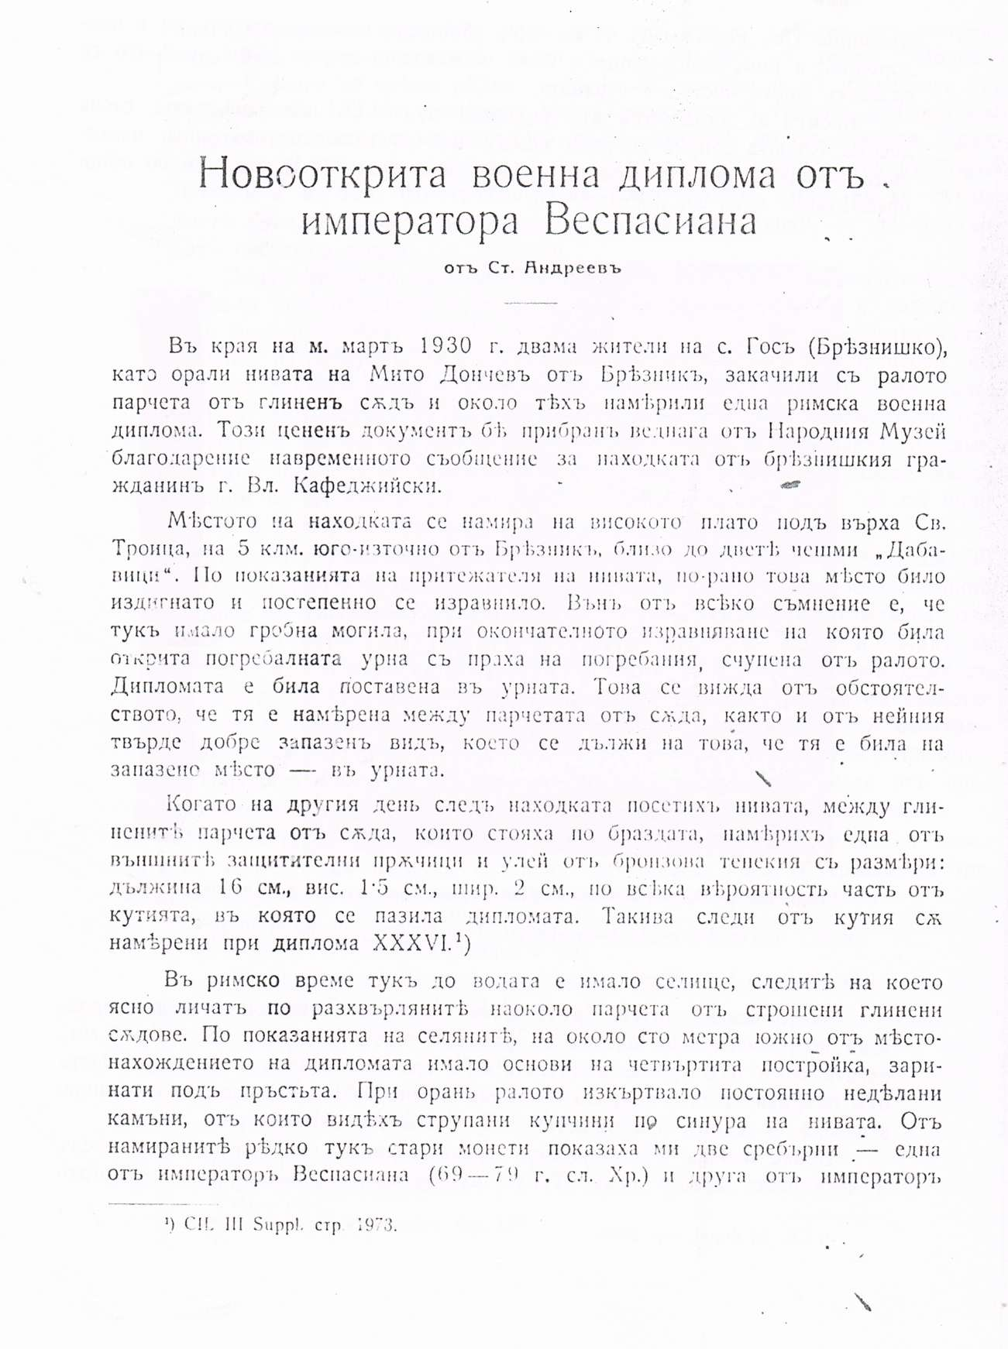

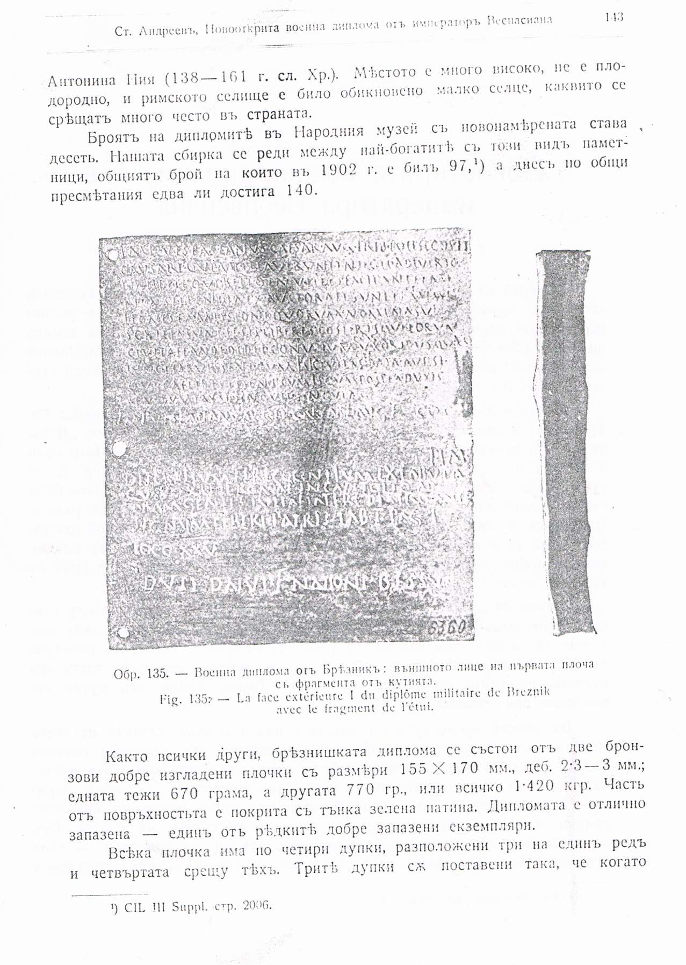

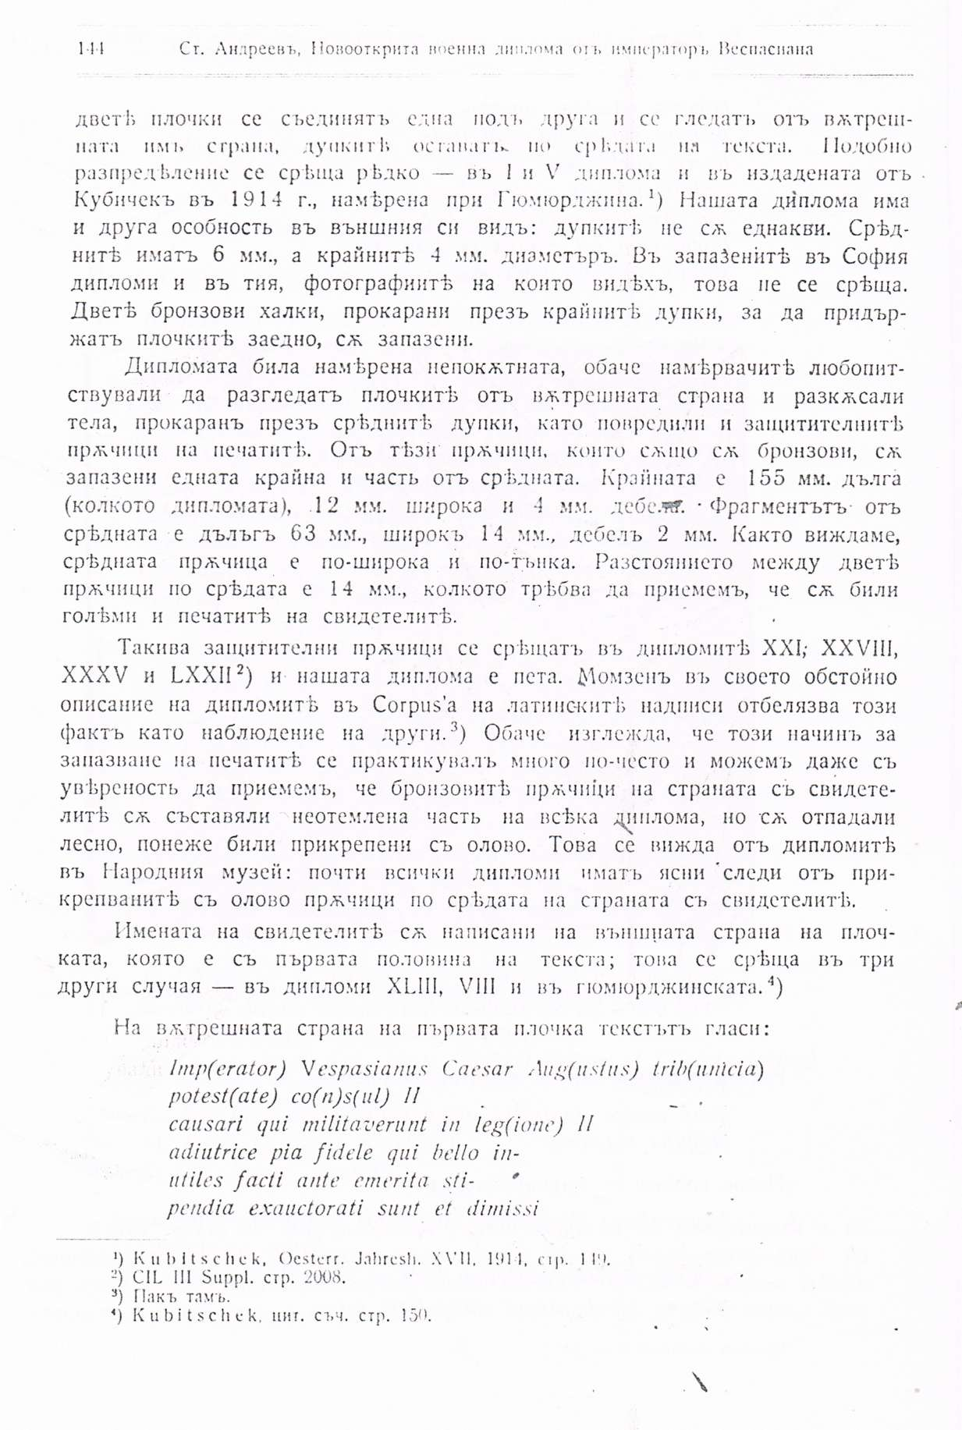

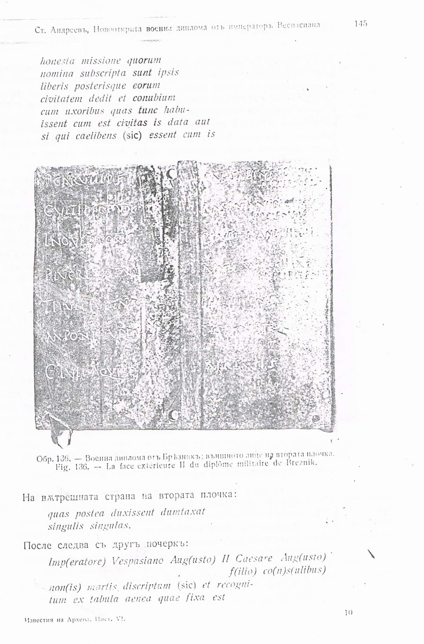

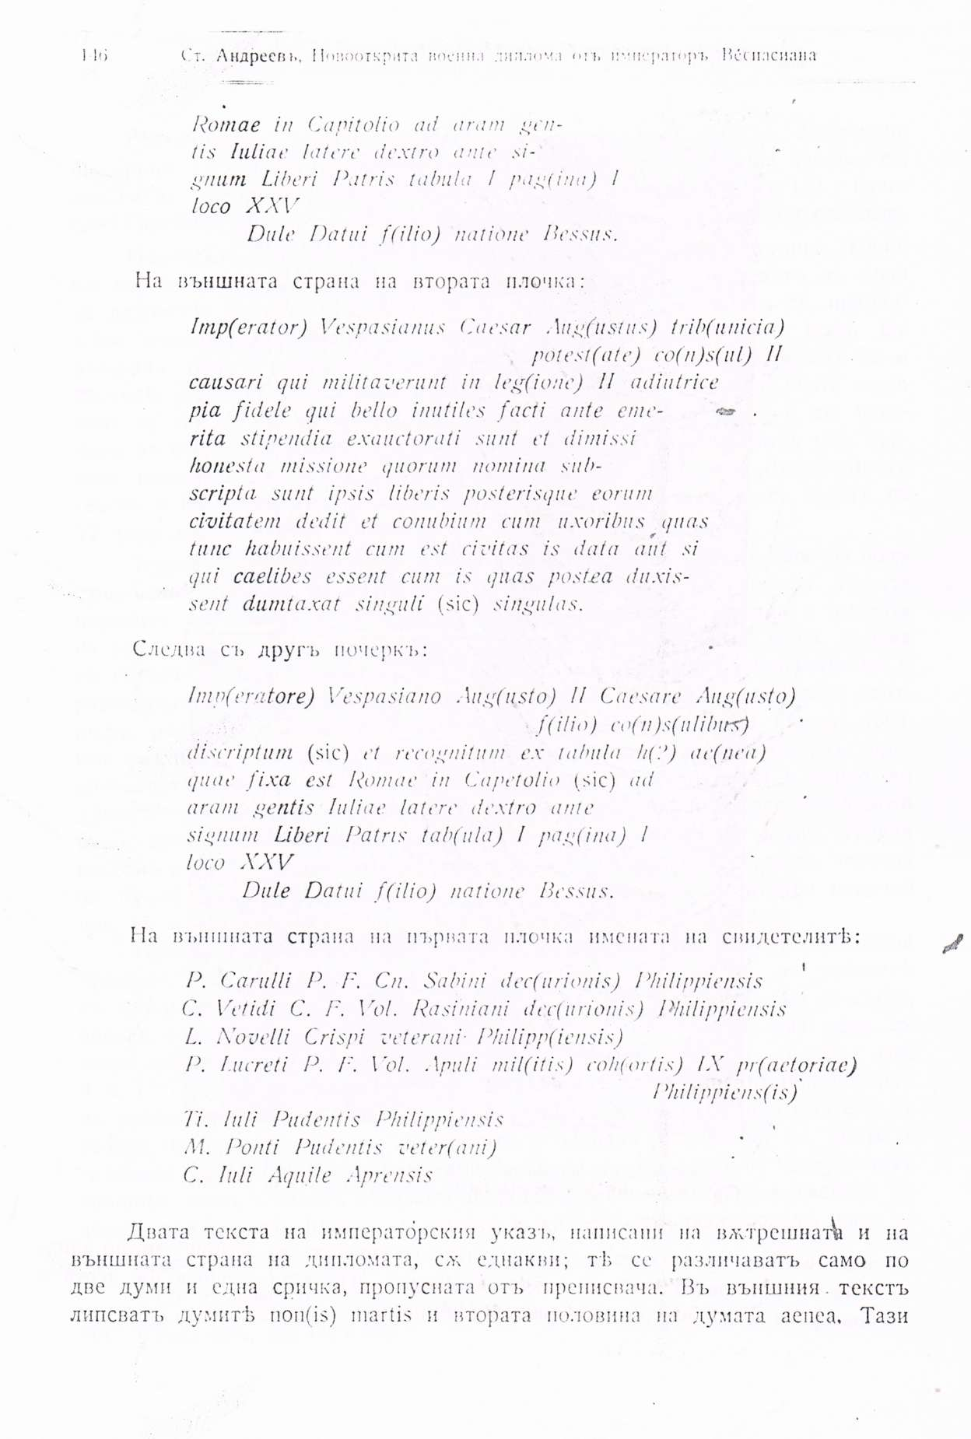

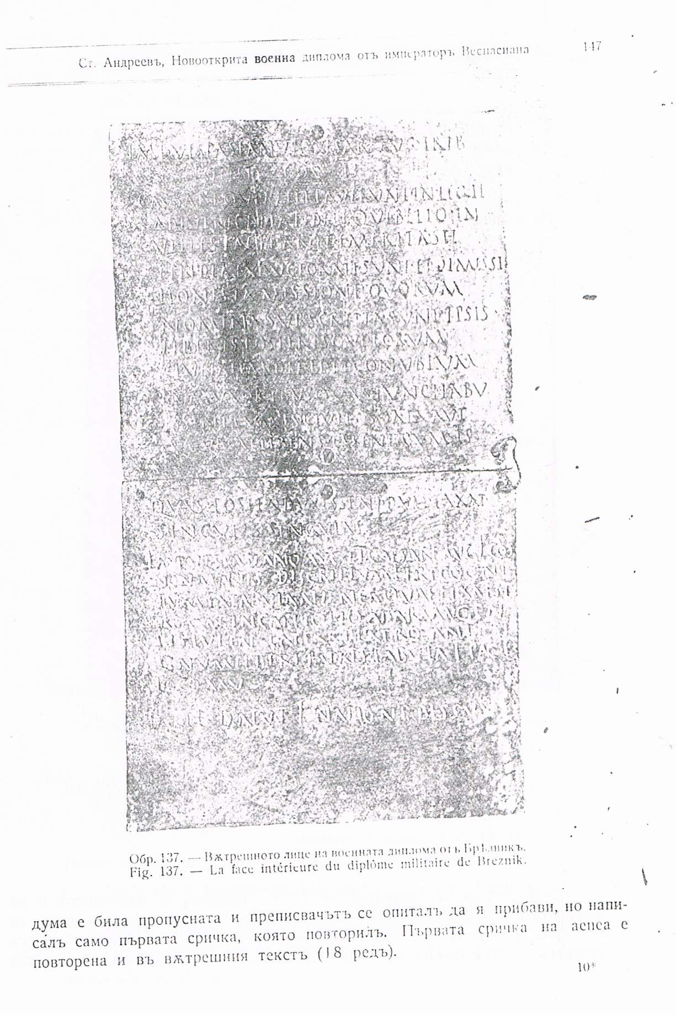

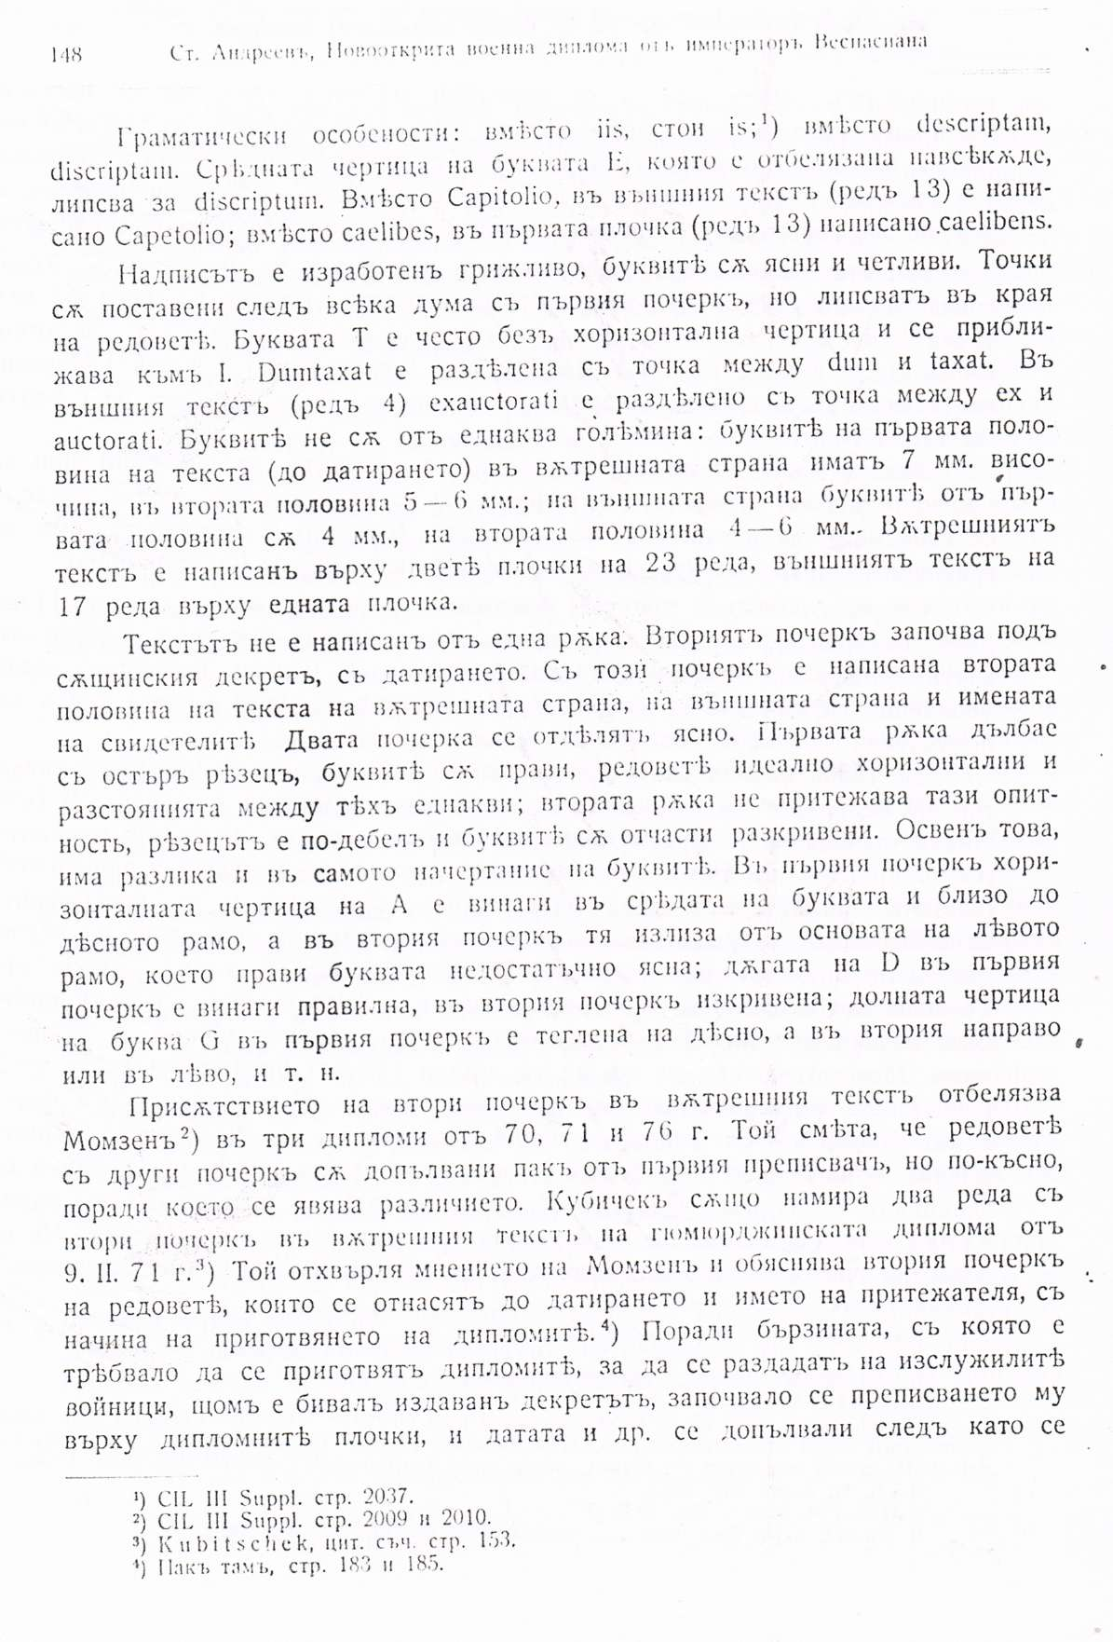

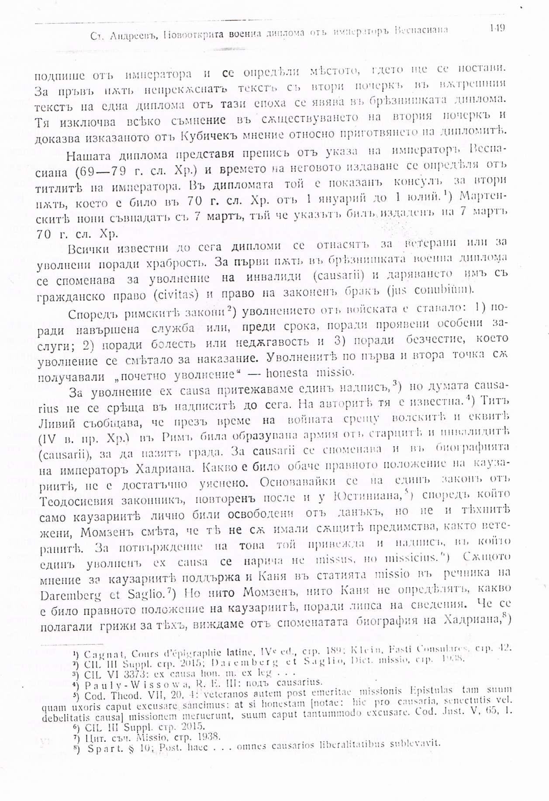

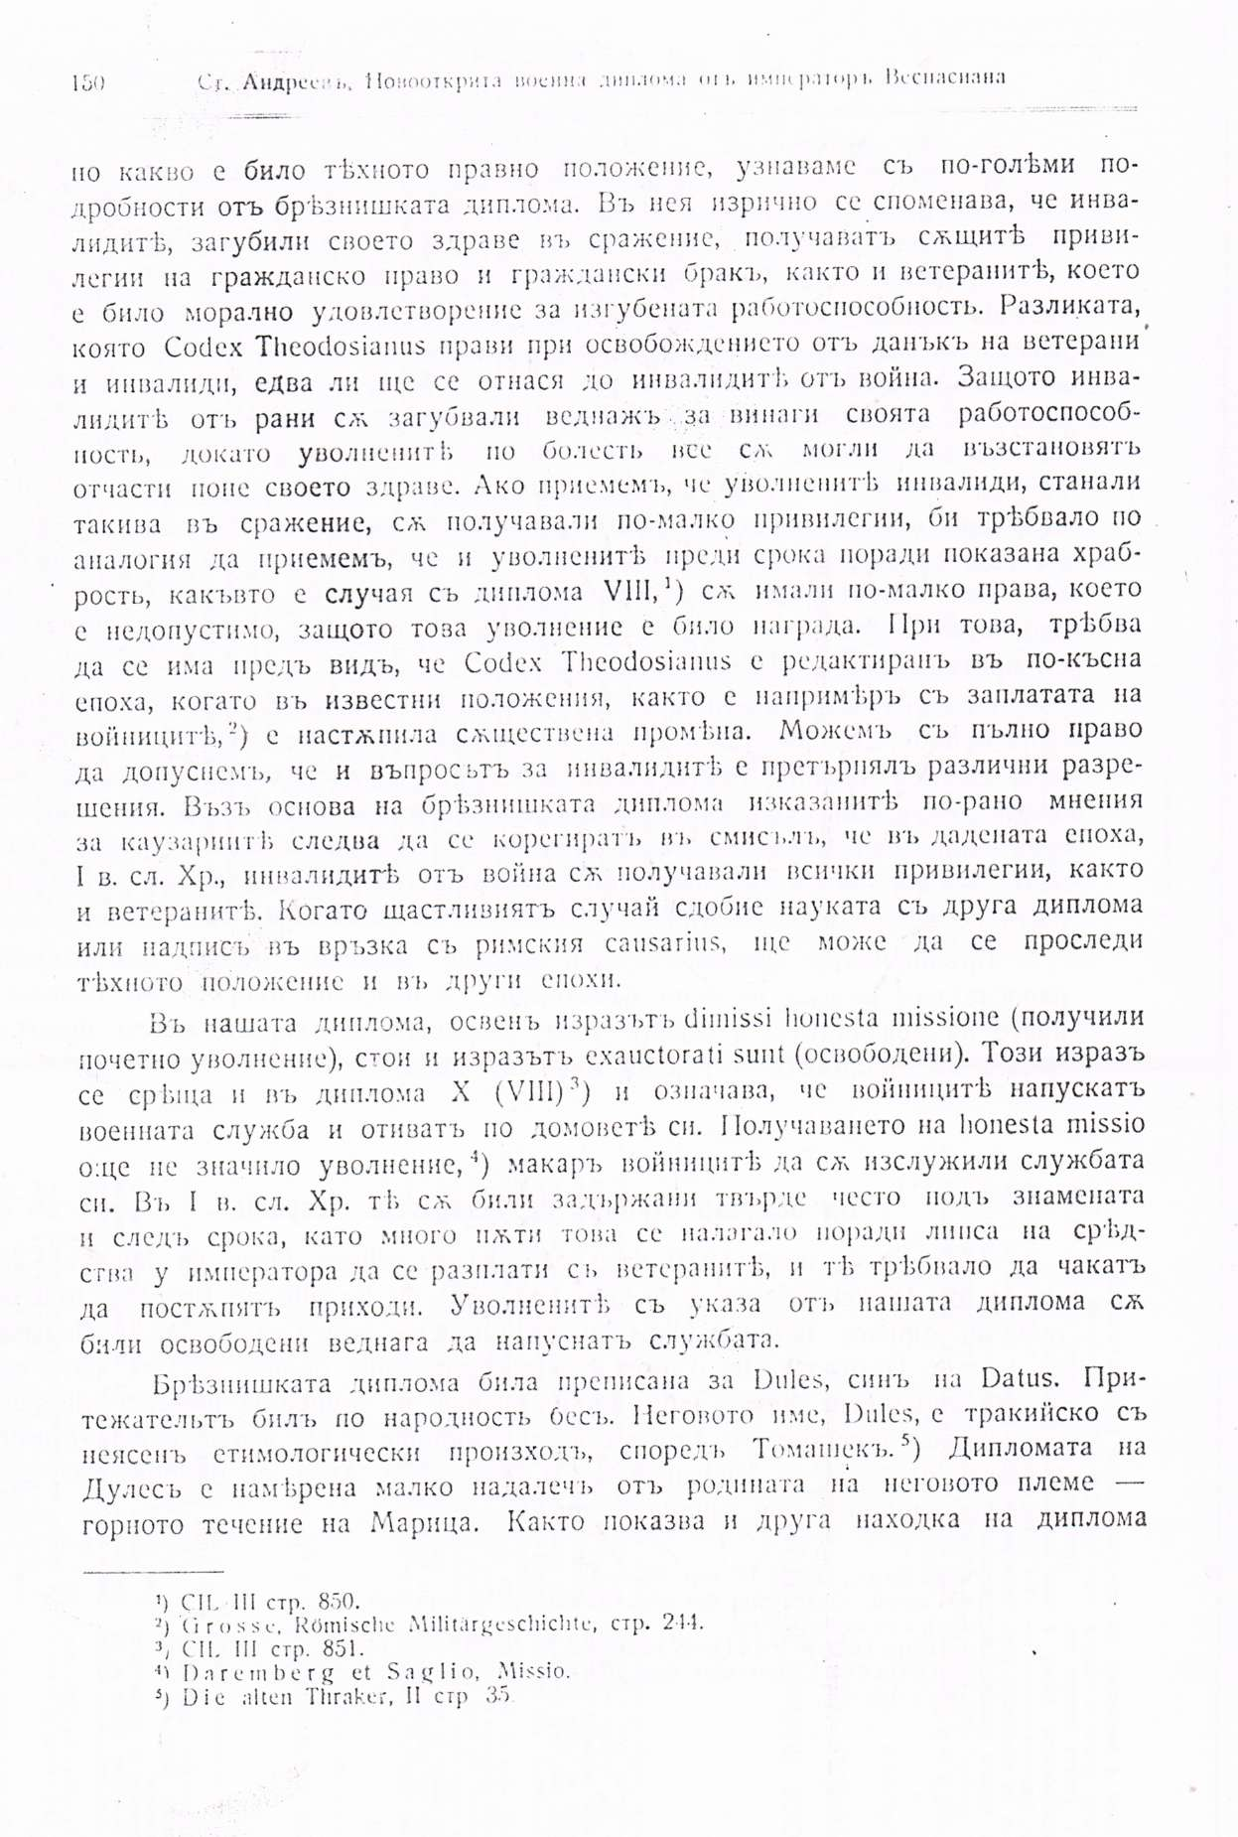

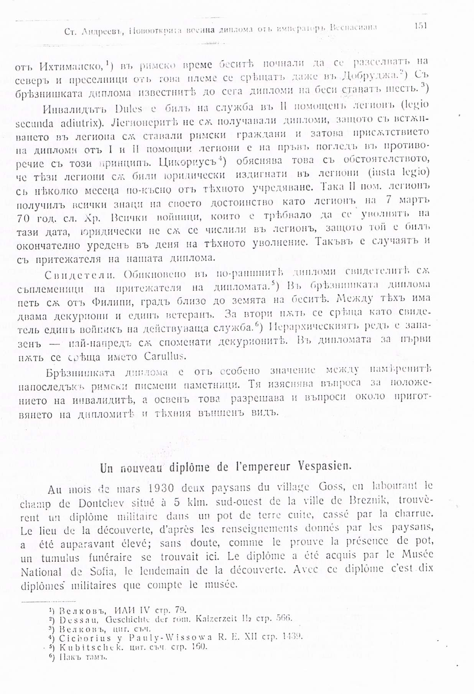

Андреев, Ст. Новооткрита военна диплома от императора Веспасиана. ИАИ, VІ, 1930, с. 142-151.

INCLUDEPICTURE "http://t0.gstatic.com/images?q=tbn:ANd9GcTDT1jpfS6n_Y4NmsXFnf0dV2uAk854tEHeOSaIXPxUCt7qxHu5xaSaZA" \* MERGEFORMATINET INCLUDEPICTURE "http://t0.gstatic.com/images?q=tbn:ANd9GcTDT1jpfS6n_Y4NmsXFnf0dV2uAk854tEHeOSaIXPxUCt7qxHu5xaSaZA" \* MERGEFORMATINET INCLUDEPICTURE "http://t0.gstatic.com/images?q=tbn:ANd9GcTDT1jpfS6n_Y4NmsXFnf0dV2uAk854tEHeOSaIXPxUCt7qxHu5xaSaZA" \* MERGEFORMATINET INCLUDEPICTURE "http://t0.gstatic.com/images?q=tbn:ANd9GcTDT1jpfS6n_Y4NmsXFnf0dV2uAk854tEHeOSaIXPxUCt7qxHu5xaSaZA" \* MERGEFORMATINET INCLUDEPICTURE "http://t0.gstatic.com/images?q=tbn:ANd9GcTDT1jpfS6n_Y4NmsXFnf0dV2uAk854tEHeOSaIXPxUCt7qxHu5xaSaZA" \* MERGEFORMATINET INCLUDEPICTURE "http://t0.gstatic.com/images?q=tbn:ANd9GcTDT1jpfS6n_Y4NmsXFnf0dV2uAk854tEHeOSaIXPxUCt7qxHu5xaSaZA" \* MERGEFORMATINET INCLUDEPICTURE "http://t0.gstatic.com/images?q=tbn:ANd9GcTDT1jpfS6n_Y4NmsXFnf0dV2uAk854tEHeOSaIXPxUCt7qxHu5xaSaZA" \* MERGEFORMATINET INCLUDEPICTURE "http://t0.gstatic.com/images?q=tbn:ANd9GcTDT1jpfS6n_Y4NmsXFnf0dV2uAk854tEHeOSaIXPxUCt7qxHu5xaSaZA" \* MERGEFORMATINET INCLUDEPICTURE "http://t0.gstatic.com/images?q=tbn:ANd9GcTDT1jpfS6n_Y4NmsXFnf0dV2uAk854tEHeOSaIXPxUCt7qxHu5xaSaZA" \* MERGEFORMATINET INCLUDEPICTURE "http://t0.gstatic.com/images?q=tbn:ANd9GcTDT1jpfS6n_Y4NmsXFnf0dV2uAk854tEHeOSaIXPxUCt7qxHu5xaSaZA" \* MERGEFORMATINET INCLUDEPICTURE "http://t0.gstatic.com/images?q=tbn:ANd9GcTDT1jpfS6n_Y4NmsXFnf0dV2uAk854tEHeOSaIXPxUCt7qxHu5xaSaZA" \* MERGEFORMATINET INCLUDEPICTURE "http://t0.gstatic.com/images?q=tbn:ANd9GcTDT1jpfS6n_Y4NmsXFnf0dV2uAk854tEHeOSaIXPxUCt7qxHu5xaSaZA" \* MERGEFORMATINET INCLUDEPICTURE "http://t0.gstatic.com/images?q=tbn:ANd9GcTDT1jpfS6n_Y4NmsXFnf0dV2uAk854tEHeOSaIXPxUCt7qxHu5xaSaZA" \* MERGEFORMATINET INCLUDEPICTURE "http://t0.gstatic.com/images?q=tbn:ANd9GcTDT1jpfS6n_Y4NmsXFnf0dV2uAk854tEHeOSaIXPxUCt7qxHu5xaSaZA" \* MERGEFORMATINET INCLUDEPICTURE "http://t0.gstatic.com/images?q=tbn:ANd9GcTDT1jpfS6n_Y4NmsXFnf0dV2uAk854tEHeOSaIXPxUCt7qxHu5xaSaZA" \* MERGEFORMATINET INCLUDEPICTURE "http://t0.gstatic.com/images?q=tbn:ANd9GcTDT1jpfS6n_Y4NmsXFnf0dV2uAk854tEHeOSaIXPxUCt7qxHu5xaSaZA" \* MERGEFORMATINET INCLUDEPICTURE "http://t0.gstatic.com/images?q=tbn:ANd9GcTDT1jpfS6n_Y4NmsXFnf0dV2uAk854tEHeOSaIXPxUCt7qxHu5xaSaZA" \* MERGEFORMATINET INCLUDEPICTURE "http://t0.gstatic.com/images?q=tbn:ANd9GcTDT1jpfS6n_Y4NmsXFnf0dV2uAk854tEHeOSaIXPxUCt7qxHu5xaSaZA" \* MERGEFORMATINET INCLUDEPICTURE "http://t0.gstatic.com/images?q=tbn:ANd9GcTDT1jpfS6n_Y4NmsXFnf0dV2uAk854tEHeOSaIXPxUCt7qxHu5xaSaZA" \* MERGEFORMATINET INCLUDEPICTURE "http://t0.gstatic.com/images?q=tbn:ANd9GcTDT1jpfS6n_Y4NmsXFnf0dV2uAk854tEHeOSaIXPxUCt7qxHu5xaSaZA" \* MERGEFORMATINET INCLUDEPICTURE "http://t0.gstatic.com/images?q=tbn:ANd9GcTDT1jpfS6n_Y4NmsXFnf0dV2uAk854tEHeOSaIXPxUCt7qxHu5xaSaZA" \* MERGEFORMATINET INCLUDEPICTURE "http://t0.gstatic.com/images?q=tbn:ANd9GcTDT1jpfS6n_Y4NmsXFnf0dV2uAk854tEHeOSaIXPxUCt7qxHu5xaSaZA" \* MERGEFORMATINET INCLUDEPICTURE "http://t0.gstatic.com/images?q=tbn:ANd9GcTDT1jpfS6n_Y4NmsXFnf0dV2uAk854tEHeOSaIXPxUCt7qxHu5xaSaZA" \* MERGEFORMATINET INCLUDEPICTURE "http://t0.gstatic.com/images?q=tbn:ANd9GcTDT1jpfS6n_Y4NmsXFnf0dV2uAk854tEHeOSaIXPxUCt7qxHu5xaSaZA" \* MERGEFORMATINET INCLUDEPICTURE "http://t0.gstatic.com/images?q=tbn:ANd9GcTDT1jpfS6n_Y4NmsXFnf0dV2uAk854tEHeOSaIXPxUCt7qxHu5xaSaZA" \* MERGEFORMATINET INCLUDEPICTURE "http://t0.gstatic.com/images?q=tbn:ANd9GcTDT1jpfS6n_Y4NmsXFnf0dV2uAk854tEHeOSaIXPxUCt7qxHu5xaSaZA" \* MERGEFORMATINET INCLUDEPICTURE "http://t0.gstatic.com/images?q=tbn:ANd9GcTDT1jpfS6n_Y4NmsXFnf0dV2uAk854tEHeOSaIXPxUCt7qxHu5xaSaZA" \* MERGEFORMATINET INCLUDEPICTURE "http://t0.gstatic.com/images?q=tbn:ANd9GcTDT1jpfS6n_Y4NmsXFnf0dV2uAk854tEHeOSaIXPxUCt7qxHu5xaSaZA" \* MERGEFORMATINET INCLUDEPICTURE "http://t0.gstatic.com/images?q=tbn:ANd9GcTDT1jpfS6n_Y4NmsXFnf0dV2uAk854tEHeOSaIXPxUCt7qxHu5xaSaZA" \* MERGEFORMATINET INCLUDEPICTURE "http://t0.gstatic.com/images?q=tbn:ANd9GcTDT1jpfS6n_Y4NmsXFnf0dV2uAk854tEHeOSaIXPxUCt7qxHu5xaSaZA" \* MERGEFORMATINET INCLUDEPICTURE "http://t0.gstatic.com/images?q=tbn:ANd9GcTDT1jpfS6n_Y4NmsXFnf0dV2uAk854tEHeOSaIXPxUCt7qxHu5xaSaZA" \* MERGEFORMATINET INCLUDEPICTURE "http://t0.gstatic.com/images?q=tbn:ANd9GcTDT1jpfS6n_Y4NmsXFnf0dV2uAk854tEHeOSaIXPxUCt7qxHu5xaSaZA" \* MERGEFORMATINET INCLUDEPICTURE "http://t0.gstatic.com/images?q=tbn:ANd9GcTDT1jpfS6n_Y4NmsXFnf0dV2uAk854tEHeOSaIXPxUCt7qxHu5xaSaZA" \* MERGEFORMATINET INCLUDEPICTURE "http://t0.gstatic.com/images?q=tbn:ANd9GcTDT1jpfS6n_Y4NmsXFnf0dV2uAk854tEHeOSaIXPxUCt7qxHu5xaSaZA" \* MERGEFORMATINET INCLUDEPICTURE "http://t0.gstatic.com/images?q=tbn:ANd9GcTDT1jpfS6n_Y4NmsXFnf0dV2uAk854tEHeOSaIXPxUCt7qxHu5xaSaZA" \* MERGEFORMATINET INCLUDEPICTURE "http://t0.gstatic.com/images?q=tbn:ANd9GcTDT1jpfS6n_Y4NmsXFnf0dV2uAk854tEHeOSaIXPxUCt7qxHu5xaSaZA" \* MERGEFORMATINET INCLUDEPICTURE "http://t0.gstatic.com/images?q=tbn:ANd9GcTDT1jpfS6n_Y4NmsXFnf0dV2uAk854tEHeOSaIXPxUCt7qxHu5xaSaZA" \* MERGEFORMATINET INCLUDEPICTURE "http://t0.gstatic.com/images?q=tbn:ANd9GcTDT1jpfS6n_Y4NmsXFnf0dV2uAk854tEHeOSaIXPxUCt7qxHu5xaSaZA" \* MERGEFORMATINET INCLUDEPICTURE "http://t0.gstatic.com/images?q=tbn:ANd9GcTDT1jpfS6n_Y4NmsXFnf0dV2uAk854tEHeOSaIXPxUCt7qxHu5xaSaZA" \* MERGEFORMATINET INCLUDEPICTURE "http://t0.gstatic.com/images?q=tbn:ANd9GcTDT1jpfS6n_Y4NmsXFnf0dV2uAk854tEHeOSaIXPxUCt7qxHu5xaSaZA" \* MERGEFORMATINET INCLUDEPICTURE "http://t0.gstatic.com/images?q=tbn:ANd9GcTDT1jpfS6n_Y4NmsXFnf0dV2uAk854tEHeOSaIXPxUCt7qxHu5xaSaZA" \* MERGEFORMATINET INCLUDEPICTURE "http://t0.gstatic.com/images?q=tbn:ANd9GcTDT1jpfS6n_Y4NmsXFnf0dV2uAk854tEHeOSaIXPxUCt7qxHu5xaSaZA" \* MERGEFORMATINET INCLUDEPICTURE "http://t0.gstatic.com/images?q=tbn:ANd9GcTDT1jpfS6n_Y4NmsXFnf0dV2uAk854tEHeOSaIXPxUCt7qxHu5xaSaZA" \* MERGEFORMATINET INCLUDEPICTURE "http://t0.gstatic.com/images?q=tbn:ANd9GcTDT1jpfS6n_Y4NmsXFnf0dV2uAk854tEHeOSaIXPxUCt7qxHu5xaSaZA" \* MERGEFORMATINET INCLUDEPICTURE "http://t0.gstatic.com/images?q=tbn:ANd9GcTDT1jpfS6n_Y4NmsXFnf0dV2uAk854tEHeOSaIXPxUCt7qxHu5xaSaZA" \* MERGEFORMATINET INCLUDEPICTURE "http://t0.gstatic.com/images?q=tbn:ANd9GcTDT1jpfS6n_Y4NmsXFnf0dV2uAk854tEHeOSaIXPxUCt7qxHu5xaSaZA" \* MERGEFORMATINET INCLUDEPICTURE "http://t0.gstatic.com/images?q=tbn:ANd9GcTDT1jpfS6n_Y4NmsXFnf0dV2uAk854tEHeOSaIXPxUCt7qxHu5xaSaZA" \* MERGEFORMATINET INCLUDEPICTURE "http://t0.gstatic.com/images?q=tbn:ANd9GcTDT1jpfS6n_Y4NmsXFnf0dV2uAk854tEHeOSaIXPxUCt7qxHu5xaSaZA" \* MERGEFORMATINET INCLUDEPICTURE "http://t0.gstatic.com/images?q=tbn:ANd9GcTDT1jpfS6n_Y4NmsXFnf0dV2uAk854tEHeOSaIXPxUCt7qxHu5xaSaZA" \* MERGEFORMATINET INCLUDEPICTURE "http://t0.gstatic.com/images?q=tbn:ANd9GcTDT1jpfS6n_Y4NmsXFnf0dV2uAk854tEHeOSaIXPxUCt7qxHu5xaSaZA" \* MERGEFORMATINET INCLUDEPICTURE "http://t0.gstatic.com/images?q=tbn:ANd9GcTDT1jpfS6n_Y4NmsXFnf0dV2uAk854tEHeOSaIXPxUCt7qxHu5xaSaZA" \* MERGEFORMATINET INCLUDEPICTURE "http://t0.gstatic.com/images?q=tbn:ANd9GcTDT1jpfS6n_Y4NmsXFnf0dV2uAk854tEHeOSaIXPxUCt7qxHu5xaSaZA" \* MERGEFORMATINET INCLUDEPICTURE "http://t0.gstatic.com/images?q=tbn:ANd9GcTDT1jpfS6n_Y4NmsXFnf0dV2uAk854tEHeOSaIXPxUCt7qxHu5xaSaZA" \* MERGEFORMATINET INCLUDEPICTURE "http://t0.gstatic.com/images?q=tbn:ANd9GcTDT1jpfS6n_Y4NmsXFnf0dV2uAk854tEHeOSaIXPxUCt7qxHu5xaSaZA" \* MERGEFORMATINET INCLUDEPICTURE "http://t0.gstatic.com/images?q=tbn:ANd9GcTDT1jpfS6n_Y4NmsXFnf0dV2uAk854tEHeOSaIXPxUCt7qxHu5xaSaZA" \* MERGEFORMATINET INCLUDEPICTURE "http://t0.gstatic.com/images?q=tbn:ANd9GcTDT1jpfS6n_Y4NmsXFnf0dV2uAk854tEHeOSaIXPxUCt7qxHu5xaSaZA" \* MERGEFORMATINET INCLUDEPICTURE "http://t0.gstatic.com/images?q=tbn:ANd9GcTDT1jpfS6n_Y4NmsXFnf0dV2uAk854tEHeOSaIXPxUCt7qxHu5xaSaZA" \* MERGEFORMATINET INCLUDEPICTURE "http://t0.gstatic.com/images?q=tbn:ANd9GcTDT1jpfS6n_Y4NmsXFnf0dV2uAk854tEHeOSaIXPxUCt7qxHu5xaSaZA" \* MERGEFORMATINET INCLUDEPICTURE "http://t0.gstatic.com/images?q=tbn:ANd9GcTDT1jpfS6n_Y4NmsXFnf0dV2uAk854tEHeOSaIXPxUCt7qxHu5xaSaZA" \* MERGEFORMATINET INCLUDEPICTURE "http://t0.gstatic.com/images?q=tbn:ANd9GcTDT1jpfS6n_Y4NmsXFnf0dV2uAk854tEHeOSaIXPxUCt7qxHu5xaSaZA" \* MERGEFORMATINET INCLUDEPICTURE "http://t0.gstatic.com/images?q=tbn:ANd9GcTDT1jpfS6n_Y4NmsXFnf0dV2uAk854tEHeOSaIXPxUCt7qxHu5xaSaZA" \* MERGEFORMATINET INCLUDEPICTURE "http://t0.gstatic.com/images?q=tbn:ANd9GcTDT1jpfS6n_Y4NmsXFnf0dV2uAk854tEHeOSaIXPxUCt7qxHu5xaSaZA" \* MERGEFORMATINET INCLUDEPICTURE "http://t0.gstatic.com/images?q=tbn:ANd9GcTDT1jpfS6n_Y4NmsXFnf0dV2uAk854tEHeOSaIXPxUCt7qxHu5xaSaZA" \* MERGEFORMATINET INCLUDEPICTURE "http://t0.gstatic.com/images?q=tbn:ANd9GcTDT1jpfS6n_Y4NmsXFnf0dV2uAk854tEHeOSaIXPxUCt7qxHu5xaSaZA" \* MERGEFORMATINET INCLUDEPICTURE "http://t0.gstatic.com/images?q=tbn:ANd9GcTDT1jpfS6n_Y4NmsXFnf0dV2uAk854tEHeOSaIXPxUCt7qxHu5xaSaZA" \* MERGEFORMATINET INCLUDEPICTURE "http://t0.gstatic.com/images?q=tbn:ANd9GcTDT1jpfS6n_Y4NmsXFnf0dV2uAk854tEHeOSaIXPxUCt7qxHu5xaSaZA" \* MERGEFORMATINET INCLUDEPICTURE "http://t0.gstatic.com/images?q=tbn:ANd9GcTDT1jpfS6n_Y4NmsXFnf0dV2uAk854tEHeOSaIXPxUCt7qxHu5xaSaZA" \* MERGEFORMATINET INCLUDEPICTURE "http://t0.gstatic.com/images?q=tbn:ANd9GcTDT1jpfS6n_Y4NmsXFnf0dV2uAk854tEHeOSaIXPxUCt7qxHu5xaSaZA" \* MERGEFORMATINET INCLUDEPICTURE "http://t0.gstatic.com/images?q=tbn:ANd9GcTDT1jpfS6n_Y4NmsXFnf0dV2uAk854tEHeOSaIXPxUCt7qxHu5xaSaZA" \* MERGEFORMATINET INCLUDEPICTURE "http://t0.gstatic.com/images?q=tbn:ANd9GcTDT1jpfS6n_Y4NmsXFnf0dV2uAk854tEHeOSaIXPxUCt7qxHu5xaSaZA" \* MERGEFORMATINET INCLUDEPICTURE "http://t0.gstatic.com/images?q=tbn:ANd9GcTDT1jpfS6n_Y4NmsXFnf0dV2uAk854tEHeOSaIXPxUCt7qxHu5xaSaZA" \* MERGEFORMATINET INCLUDEPICTURE "http://t0.gstatic.com/images?q=tbn:ANd9GcTDT1jpfS6n_Y4NmsXFnf0dV2uAk854tEHeOSaIXPxUCt7qxHu5xaSaZA" \* MERGEFORMATINET INCLUDEPICTURE "http://t0.gstatic.com/images?q=tbn:ANd9GcTDT1jpfS6n_Y4NmsXFnf0dV2uAk854tEHeOSaIXPxUCt7qxHu5xaSaZA" \* MERGEFORMATINET INCLUDEPICTURE "http://t0.gstatic.com/images?q=tbn:ANd9GcTDT1jpfS6n_Y4NmsXFnf0dV2uAk854tEHeOSaIXPxUCt7qxHu5xaSaZA" \* MERGEFORMATINET INCLUDEPICTURE "http://t0.gstatic.com/images?q=tbn:ANd9GcTDT1jpfS6n_Y4NmsXFnf0dV2uAk854tEHeOSaIXPxUCt7qxHu5xaSaZA" \* MERGEFORMATINET INCLUDEPICTURE "http://t0.gstatic.com/images?q=tbn:ANd9GcTDT1jpfS6n_Y4NmsXFnf0dV2uAk854tEHeOSaIXPxUCt7qxHu5xaSaZA" \* MERGEFORMATINET INCLUDEPICTURE "http://t0.gstatic.com/images?q=tbn:ANd9GcTDT1jpfS6n_Y4NmsXFnf0dV2uAk854tEHeOSaIXPxUCt7qxHu5xaSaZA" \* MERGEFORMATINET INCLUDEPICTURE "http://t0.gstatic.com/images?q=tbn:ANd9GcTDT1jpfS6n_Y4NmsXFnf0dV2uAk854tEHeOSaIXPxUCt7qxHu5xaSaZA" \* MERGEFORMATINET INCLUDEPICTURE "http://t0.gstatic.com/images?q=tbn:ANd9GcTDT1jpfS6n_Y4NmsXFnf0dV2uAk854tEHeOSaIXPxUCt7qxHu5xaSaZA" \* MERGEFORMATINET INCLUDEPICTURE "http://t0.gstatic.com/images?q=tbn:ANd9GcTDT1jpfS6n_Y4NmsXFnf0dV2uAk854tEHeOSaIXPxUCt7qxHu5xaSaZA" \* MERGEFORMATINET INCLUDEPICTURE "http://t0.gstatic.com/images?q=tbn:ANd9GcTDT1jpfS6n_Y4NmsXFnf0dV2uAk854tEHeOSaIXPxUCt7qxHu5xaSaZA" \* MERGEFORMATINET INCLUDEPICTURE "http://t0.gstatic.com/images?q=tbn:ANd9GcTDT1jpfS6n_Y4NmsXFnf0dV2uAk854tEHeOSaIXPxUCt7qxHu5xaSaZA" \* MERGEFORMATINET INCLUDEPICTURE "http://t0.gstatic.com/images?q=tbn:ANd9GcTDT1jpfS6n_Y4NmsXFnf0dV2uAk854tEHeOSaIXPxUCt7qxHu5xaSaZA" \* MERGEFORMATINET INCLUDEPICTURE "http://t0.gstatic.com/images?q=tbn:ANd9GcTDT1jpfS6n_Y4NmsXFnf0dV2uAk854tEHeOSaIXPxUCt7qxHu5xaSaZA" \* MERGEFORMATINET INCLUDEPICTURE "http://t0.gstatic.com/images?q=tbn:ANd9GcTDT1jpfS6n_Y4NmsXFnf0dV2uAk854tEHeOSaIXPxUCt7qxHu5xaSaZA" \* MERGEFORMATINET INCLUDEPICTURE "http://t0.gstatic.com/images?q=tbn:ANd9GcTDT1jpfS6n_Y4NmsXFnf0dV2uAk854tEHeOSaIXPxUCt7qxHu5xaSaZA" \* MERGEFORMATINET INCLUDEPICTURE "http://t0.gstatic.com/images?q=tbn:ANd9GcTDT1jpfS6n_Y4NmsXFnf0dV2uAk854tEHeOSaIXPxUCt7qxHu5xaSaZA" \* MERGEFORMATINET INCLUDEPICTURE "http://t0.gstatic.com/images?q=tbn:ANd9GcTDT1jpfS6n_Y4NmsXFnf0dV2uAk854tEHeOSaIXPxUCt7qxHu5xaSaZA" \* MERGEFORMATINET INCLUDEPICTURE "http://t0.gstatic.com/images?q=tbn:ANd9GcTDT1jpfS6n_Y4NmsXFnf0dV2uAk854tEHeOSaIXPxUCt7qxHu5xaSaZA" \* MERGEFORMATINET INCLUDEPICTURE "http://t0.gstatic.com/images?q=tbn:ANd9GcTDT1jpfS6n_Y4NmsXFnf0dV2uAk854tEHeOSaIXPxUCt7qxHu5xaSaZA" \* MERGEFORMATINET INCLUDEPICTURE "http://t0.gstatic.com/images?q=tbn:ANd9GcTDT1jpfS6n_Y4NmsXFnf0dV2uAk854tEHeOSaIXPxUCt7qxHu5xaSaZA" \* MERGEFORMATINET INCLUDEPICTURE "http://t0.gstatic.com/images?q=tbn:ANd9GcTDT1jpfS6n_Y4NmsXFnf0dV2uAk854tEHeOSaIXPxUCt7qxHu5xaSaZA" \* MERGEFORMATINET INCLUDEPICTURE "http://t0.gstatic.com/images?q=tbn:ANd9GcTDT1jpfS6n_Y4NmsXFnf0dV2uAk854tEHeOSaIXPxUCt7qxHu5xaSaZA" \* MERGEFORMATINET INCLUDEPICTURE "http://t0.gstatic.com/images?q=tbn:ANd9GcTDT1jpfS6n_Y4NmsXFnf0dV2uAk854tEHeOSaIXPxUCt7qxHu5xaSaZA" \* MERGEFORMATINET INCLUDEPICTURE "http://t0.gstatic.com/images?q=tbn:ANd9GcTDT1jpfS6n_Y4NmsXFnf0dV2uAk854tEHeOSaIXPxUCt7qxHu5xaSaZA" \* MERGEFORMATINET INCLUDEPICTURE "http://t0.gstatic.com/images?q=tbn:ANd9GcTDT1jpfS6n_Y4NmsXFnf0dV2uAk854tEHeOSaIXPxUCt7qxHu5xaSaZA" \* MERGEFORMATINET INCLUDEPICTURE "http://t0.gstatic.com/images?q=tbn:ANd9GcTDT1jpfS6n_Y4NmsXFnf0dV2uAk854tEHeOSaIXPxUCt7qxHu5xaSaZA" \* MERGEFORMATINET INCLUDEPICTURE "http://t0.gstatic.com/images?q=tbn:ANd9GcTDT1jpfS6n_Y4NmsXFnf0dV2uAk854tEHeOSaIXPxUCt7qxHu5xaSaZA" \* MERGEFORMATINET INCLUDEPICTURE "http://t0.gstatic.com/images?q=tbn:ANd9GcTDT1jpfS6n_Y4NmsXFnf0dV2uAk854tEHeOSaIXPxUCt7qxHu5xaSaZA" \* MERGEFORMATINET INCLUDEPICTURE "http://t0.gstatic.com/images?q=tbn:ANd9GcTDT1jpfS6n_Y4NmsXFnf0dV2uAk854tEHeOSaIXPxUCt7qxHu5xaSaZA" \* MERGEFORMATINET INCLUDEPICTURE "http://t0.gstatic.com/images?q=tbn:ANd9GcTDT1jpfS6n_Y4NmsXFnf0dV2uAk854tEHeOSaIXPxUCt7qxHu5xaSaZA" \* MERGEFORMATINET INCLUDEPICTURE "http://t0.gstatic.com/images?q=tbn:ANd9GcTDT1jpfS6n_Y4NmsXFnf0dV2uAk854tEHeOSaIXPxUCt7qxHu5xaSaZA" \* MERGEFORMATINET INCLUDEPICTURE "http://t0.gstatic.com/images?q=tbn:ANd9GcTDT1jpfS6n_Y4NmsXFnf0dV2uAk854tEHeOSaIXPxUCt7qxHu5xaSaZA" \* MERGEFORMATINET INCLUDEPICTURE "http://t0.gstatic.com/images?q=tbn:ANd9GcTDT1jpfS6n_Y4NmsXFnf0dV2uAk854tEHeOSaIXPxUCt7qxHu5xaSaZA" \* MERGEFORMATINET INCLUDEPICTURE "http://t0.gstatic.com/images?q=tbn:ANd9GcTDT1jpfS6n_Y4NmsXFnf0dV2uAk854tEHeOSaIXPxUCt7qxHu5xaSaZA" \* MERGEFORMATINET INCLUDEPICTURE "http://t0.gstatic.com/images?q=tbn:ANd9GcTDT1jpfS6n_Y4NmsXFnf0dV2uAk854tEHeOSaIXPxUCt7qxHu5xaSaZA" \* MERGEFORMATINET INCLUDEPICTURE "http://t0.gstatic.com/images?q=tbn:ANd9GcTDT1jpfS6n_Y4NmsXFnf0dV2uAk854tEHeOSaIXPxUCt7qxHu5xaSaZA" \* MERGEFORMATINET INCLUDEPICTURE "http://t0.gstatic.com/images?q=tbn:ANd9GcTDT1jpfS6n_Y4NmsXFnf0dV2uAk854tEHeOSaIXPxUCt7qxHu5xaSaZA" \* MERGEFORMATINET INCLUDEPICTURE "http://t0.gstatic.com/images?q=tbn:ANd9GcTDT1jpfS6n_Y4NmsXFnf0dV2uAk854tEHeOSaIXPxUCt7qxHu5xaSaZA" \* MERGEFORMATINET INCLUDEPICTURE "http://t0.gstatic.com/images?q=tbn:ANd9GcTDT1jpfS6n_Y4NmsXFnf0dV2uAk854tEHeOSaIXPxUCt7qxHu5xaSaZA" \* MERGEFORMATINET INCLUDEPICTURE "http://t0.gstatic.com/images?q=tbn:ANd9GcTDT1jpfS6n_Y4NmsXFnf0dV2uAk854tEHeOSaIXPxUCt7qxHu5xaSaZA" \* MERGEFORMATINET INCLUDEPICTURE "http://t0.gstatic.com/images?q=tbn:ANd9GcTDT1jpfS6n_Y4NmsXFnf0dV2uAk854tEHeOSaIXPxUCt7qxHu5xaSaZA" \* MERGEFORMATINET INCLUDEPICTURE "http://t0.gstatic.com/images?q=tbn:ANd9GcTDT1jpfS6n_Y4NmsXFnf0dV2uAk854tEHeOSaIXPxUCt7qxHu5xaSaZA" \* MERGEFORMATINET INCLUDEPICTURE "http://t0.gstatic.com/images?q=tbn:ANd9GcTDT1jpfS6n_Y4NmsXFnf0dV2uAk854tEHeOSaIXPxUCt7qxHu5xaSaZA" \* MERGEFORMATINET INCLUDEPICTURE "http://t0.gstatic.com/images?q=tbn:ANd9GcTDT1jpfS6n_Y4NmsXFnf0dV2uAk854tEHeOSaIXPxUCt7qxHu5xaSaZA" \* MERGEFORMATINET INCLUDEPICTURE "http://t0.gstatic.com/images?q=tbn:ANd9GcTDT1jpfS6n_Y4NmsXFnf0dV2uAk854tEHeOSaIXPxUCt7qxHu5xaSaZA" \* MERGEFORMATINET INCLUDEPICTURE "http://t0.gstatic.com/images?q=tbn:ANd9GcTDT1jpfS6n_Y4NmsXFnf0dV2uAk854tEHeOSaIXPxUCt7qxHu5xaSaZA" \* MERGEFORMATINET INCLUDEPICTURE "http://t0.gstatic.com/images?q=tbn:ANd9GcTDT1jpfS6n_Y4NmsXFnf0dV2uAk854tEHeOSaIXPxUCt7qxHu5xaSaZA" \* MERGEFORMATINET INCLUDEPICTURE "http://t0.gstatic.com/images?q=tbn:ANd9GcTDT1jpfS6n_Y4NmsXFnf0dV2uAk854tEHeOSaIXPxUCt7qxHu5xaSaZA" \* MERGEFORMATINET INCLUDEPICTURE "http://t0.gstatic.com/images?q=tbn:ANd9GcTDT1jpfS6n_Y4NmsXFnf0dV2uAk854tEHeOSaIXPxUCt7qxHu5xaSaZA" \* MERGEFORMATINET INCLUDEPICTURE "http://t0.gstatic.com/images?q=tbn:ANd9GcTDT1jpfS6n_Y4NmsXFnf0dV2uAk854tEHeOSaIXPxUCt7qxHu5xaSaZA" \* MERGEFORMATINET INCLUDEPICTURE "http://t0.gstatic.com/images?q=tbn:ANd9GcTDT1jpfS6n_Y4NmsXFnf0dV2uAk854tEHeOSaIXPxUCt7qxHu5xaSaZA" \* MERGEFORMATINET INCLUDEPICTURE "http://t0.gstatic.com/images?q=tbn:ANd9GcTDT1jpfS6n_Y4NmsXFnf0dV2uAk854tEHeOSaIXPxUCt7qxHu5xaSaZA" \* MERGEFORMATINET INCLUDEPICTURE "http://t0.gstatic.com/images?q=tbn:ANd9GcTDT1jpfS6n_Y4NmsXFnf0dV2uAk854tEHeOSaIXPxUCt7qxHu5xaSaZA" \* MERGEFORMATINET INCLUDEPICTURE "http://t0.gstatic.com/images?q=tbn:ANd9GcTDT1jpfS6n_Y4NmsXFnf0dV2uAk854tEHeOSaIXPxUCt7qxHu5xaSaZA" \* MERGEFORMATINET INCLUDEPICTURE "http://t0.gstatic.com/images?q=tbn:ANd9GcTDT1jpfS6n_Y4NmsXFnf0dV2uAk854tEHeOSaIXPxUCt7qxHu5xaSaZA" \* MERGEFORMATINET INCLUDEPICTURE "http://t0.gstatic.com/images?q=tbn:ANd9GcTDT1jpfS6n_Y4NmsXFnf0dV2uAk854tEHeOSaIXPxUCt7qxHu5xaSaZA" \* MERGEFORMATINET INCLUDEPICTURE "http://t0.gstatic.com/images?q=tbn:ANd9GcTDT1jpfS6n_Y4NmsXFnf0dV2uAk854tEHeOSaIXPxUCt7qxHu5xaSaZA" \* MERGEFORMATINET INCLUDEPICTURE "http://t0.gstatic.com/images?q=tbn:ANd9GcTDT1jpfS6n_Y4NmsXFnf0dV2uAk854tEHeOSaIXPxUCt7qxHu5xaSaZA" \* MERGEFORMATINET INCLUDEPICTURE "http://t0.gstatic.com/images?q=tbn:ANd9GcTDT1jpfS6n_Y4NmsXFnf0dV2uAk854tEHeOSaIXPxUCt7qxHu5xaSaZA" \* MERGEFORMATINET INCLUDEPICTURE "http://t0.gstatic.com/images?q=tbn:ANd9GcTDT1jpfS6n_Y4NmsXFnf0dV2uAk854tEHeOSaIXPxUCt7qxHu5xaSaZA" \* MERGEFORMATINET INCLUDEPICTURE "http://t0.gstatic.com/images?q=tbn:ANd9GcTDT1jpfS6n_Y4NmsXFnf0dV2uAk854tEHeOSaIXPxUCt7qxHu5xaSaZA" \* MERGEFORMATINET INCLUDEPICTURE "http://t0.gstatic.com/images?q=tbn:ANd9GcTDT1jpfS6n_Y4NmsXFnf0dV2uAk854tEHeOSaIXPxUCt7qxHu5xaSaZA" \* MERGEFORMATINET INCLUDEPICTURE "http://t0.gstatic.com/images?q=tbn:ANd9GcTDT1jpfS6n_Y4NmsXFnf0dV2uAk854tEHeOSaIXPxUCt7qxHu5xaSaZA" \* MERGEFORMATINET INCLUDEPICTURE "http://t0.gstatic.com/images?q=tbn:ANd9GcTDT1jpfS6n_Y4NmsXFnf0dV2uAk854tEHeOSaIXPxUCt7qxHu5xaSaZA" \* MERGEFORMATINET INCLUDEPICTURE "http://t0.gstatic.com/images?q=tbn:ANd9GcTDT1jpfS6n_Y4NmsXFnf0dV2uAk854tEHeOSaIXPxUCt7qxHu5xaSaZA" \* MERGEFORMATINET INCLUDEPICTURE "http://t0.gstatic.com/images?q=tbn:ANd9GcTDT1jpfS6n_Y4NmsXFnf0dV2uAk854tEHeOSaIXPxUCt7qxHu5xaSaZA" \* MERGEFORMATINET INCLUDEPICTURE "http://t0.gstatic.com/images?q=tbn:ANd9GcTDT1jpfS6n_Y4NmsXFnf0dV2uAk854tEHeOSaIXPxUCt7qxHu5xaSaZA" \* MERGEFORMATINET INCLUDEPICTURE "http://t0.gstatic.com/images?q=tbn:ANd9GcTDT1jpfS6n_Y4NmsXFnf0dV2uAk854tEHeOSaIXPxUCt7qxHu5xaSaZA" \* MERGEFORMATINET INCLUDEPICTURE "http://t0.gstatic.com/images?q=tbn:ANd9GcTDT1jpfS6n_Y4NmsXFnf0dV2uAk854tEHeOSaIXPxUCt7qxHu5xaSaZA" \* MERGEFORMATINET INCLUDEPICTURE "http://t0.gstatic.com/images?q=tbn:ANd9GcTDT1jpfS6n_Y4NmsXFnf0dV2uAk854tEHeOSaIXPxUCt7qxHu5xaSaZA" \* MERGEFORMATINET INCLUDEPICTURE "http://t0.gstatic.com/images?q=tbn:ANd9GcTDT1jpfS6n_Y4NmsXFnf0dV2uAk854tEHeOSaIXPxUCt7qxHu5xaSaZA" \* MERGEFORMATINET INCLUDEPICTURE "http://t0.gstatic.com/images?q=tbn:ANd9GcTDT1jpfS6n_Y4NmsXFnf0dV2uAk854tEHeOSaIXPxUCt7qxHu5xaSaZA" \* MERGEFORMATINET INCLUDEPICTURE "http://t0.gstatic.com/images?q=tbn:ANd9GcTDT1jpfS6n_Y4NmsXFnf0dV2uAk854tEHeOSaIXPxUCt7qxHu5xaSaZA" \* MERGEFORMATINET INCLUDEPICTURE "http://t0.gstatic.com/images?q=tbn:ANd9GcTDT1jpfS6n_Y4NmsXFnf0dV2uAk854tEHeOSaIXPxUCt7qxHu5xaSaZA" \* MERGEFORMATINET INCLUDEPICTURE "http://t0.gstatic.com/images?q=tbn:ANd9GcTDT1jpfS6n_Y4NmsXFnf0dV2uAk854tEHeOSaIXPxUCt7qxHu5xaSaZA" \* MERGEFORMATINET INCLUDEPICTURE "http://t0.gstatic.com/images?q=tbn:ANd9GcTDT1jpfS6n_Y4NmsXFnf0dV2uAk854tEHeOSaIXPxUCt7qxHu5xaSaZA" \* MERGEFORMATINET INCLUDEPICTURE "http://t0.gstatic.com/images?q=tbn:ANd9GcTDT1jpfS6n_Y4NmsXFnf0dV2uAk854tEHeOSaIXPxUCt7qxHu5xaSaZA" \* MERGEFORMATINET INCLUDEPICTURE "http://t0.gstatic.com/images?q=tbn:ANd9GcTDT1jpfS6n_Y4NmsXFnf0dV2uAk854tEHeOSaIXPxUCt7qxHu5xaSaZA" \* MERGEFORMATINET INCLUDEPICTURE "http://t0.gstatic.com/images?q=tbn:ANd9GcTDT1jpfS6n_Y4NmsXFnf0dV2uAk854tEHeOSaIXPxUCt7qxHu5xaSaZA" \* MERGEFORMATINET INCLUDEPICTURE "http://t0.gstatic.com/images?q=tbn:ANd9GcTDT1jpfS6n_Y4NmsXFnf0dV2uAk854tEHeOSaIXPxUCt7qxHu5xaSaZA" \* MERGEFORMATINET INCLUDEPICTURE "http://t0.gstatic.com/images?q=tbn:ANd9GcTDT1jpfS6n_Y4NmsXFnf0dV2uAk854tEHeOSaIXPxUCt7qxHu5xaSaZA" \* MERGEFORMATINET INCLUDEPICTURE "http://t0.gstatic.com/images?q=tbn:ANd9GcTDT1jpfS6n_Y4NmsXFnf0dV2uAk854tEHeOSaIXPxUCt7qxHu5xaSaZA" \* MERGEFORMATINET INCLUDEPICTURE "http://t0.gstatic.com/images?q=tbn:ANd9GcTDT1jpfS6n_Y4NmsXFnf0dV2uAk854tEHeOSaIXPxUCt7qxHu5xaSaZA" \* MERGEFORMATINET INCLUDEPICTURE "http://t0.gstatic.com/images?q=tbn:ANd9GcTDT1jpfS6n_Y4NmsXFnf0dV2uAk854tEHeOSaIXPxUCt7qxHu5xaSaZA" \* MERGEFORMATINET INCLUDEPICTURE "http://t0.gstatic.com/images?q=tbn:ANd9GcTDT1jpfS6n_Y4NmsXFnf0dV2uAk854tEHeOSaIXPxUCt7qxHu5xaSaZA" \* MERGEFORMATINET INCLUDEPICTURE "http://t0.gstatic.com/images?q=tbn:ANd9GcTDT1jpfS6n_Y4NmsXFnf0dV2uAk854tEHeOSaIXPxUCt7qxHu5xaSaZA" \* MERGEFORMATINET INCLUDEPICTURE "http://t0.gstatic.com/images?q=tbn:ANd9GcTDT1jpfS6n_Y4NmsXFnf0dV2uAk854tEHeOSaIXPxUCt7qxHu5xaSaZA" \* MERGEFORMATINET INCLUDEPICTURE "http://t0.gstatic.com/images?q=tbn:ANd9GcTDT1jpfS6n_Y4NmsXFnf0dV2uAk854tEHeOSaIXPxUCt7qxHu5xaSaZA" \* MERGEFORMATINET INCLUDEPICTURE "http://t0.gstatic.com/images?q=tbn:ANd9GcTDT1jpfS6n_Y4NmsXFnf0dV2uAk854tEHeOSaIXPxUCt7qxHu5xaSaZA" \* MERGEFORMATINET
Compiler FLN

